**CONCEPT NOTE FOR**

**COAL STOCK YARD MANAGEMENT ( CSYM)**

Coal stockyard management digital dashboard will enable operator to effectively manage coal stalking and blending with availability of data .The system will have following dashboards.

**Benefit**

1. To achieve desired coal GCV for feeding
2. To maintain healthy proportion of different range of coal GCV at stockyard.
3. To reduce aging of coal which will reduce GCV gap
4. To reduce spur intermixing in coal pile.

The system will contain

1. Coal yard overview with pile and sub pile GCV and quantity
2. Pile coal quality proportion
3. Blending, direct feeding stacking decision.
4. Available space with spur intermixing and Stalking option
5. Pile aging

**Part 1-Coal yard overview with pile and sub pile GCV and quantity:**

This dashboard will contain all 16 piles with Top and bottom. CSYM will fetch the data from excel and show each pile top bottom quantity and GCV.

Quantity to be displayed in scale and visual

GCV will be displayed in numbers with 3-color band

<3100 – Red

3100-3500- yellow

>3500 – Green

**Part 2-Pile coal quality proportion:**

The system will show the pile composition at different coal range and immediate use pile composition at different coal range.

**Available coal stock composition**

Whole pile stock is considered as available coal stock

If the percentage of available coal stock (GCV <3100) is less than 20% then the System will show “available stock quality is healthy “and if >50% then “Usable stock quality is unhealthy” else “usable stock quality is moderate”

**Immediate Usable coal stock composition**

Only top pile stock is considered as immediate usable coal stock

If the percentage of immediate coal stock (GCV <3100) is less than 20% then the System will show “Usable stock quality is healthy “and if >50% then “Usable stock quality is unhealthy” else “usable stock quality is moderate”

CSYM will show average pile GCV, top pile GCV and bottom pile GCV

**Illustration of dashboard – Pile GCV**

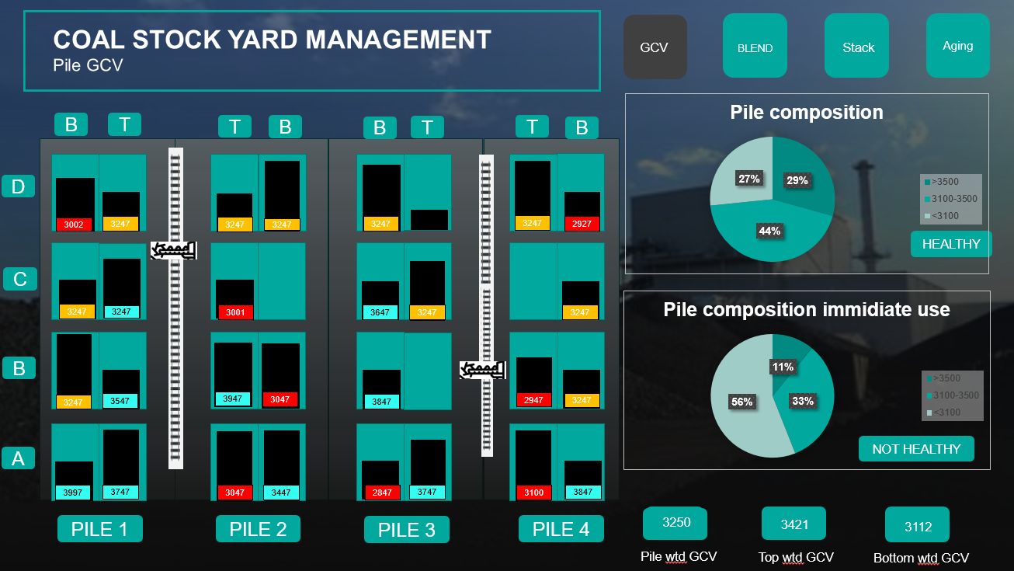

**Part -3 Direct feed ,Blending and stacking decision**

Coal is coming from 2 modes rail and road mode. Rail coal can be stacked and directly fed to the bunker. Direct feeding to the bunker has a specification of quality that is (3200 – 3400 GCV).

So direct feeding will be depended on the GCV of coal, but challenge is GCV of coal from coal spur is unknown and cannot be measured instantaneously. GCV of incoming coal to be forecasted based on recent trends and based on that blending possibility to be analyzed by (CYSM).

How CYSM will analyze blending strategy

CYSM will analyze based on 3 input to get desired quality of GCV.

1. What is incoming coal GCV
2. What is the required GCV for bunkering
3. What coal is available at site for blending
4. Coal quality composition in pile
5. Aging of pile

What is incoming coal GCV

CYSM will search last 5 rail GCV of same spur. It will give the output as average of samples if variability is < 50 Kcal. If variability is more than 50 kcal then output will be (Avg minus 50 Kcal).

**What is the required GCV for bunkering?**

Coal design GCV is 3300 Kcal /kg

Allowable deviation is range is around 5-7% - 3470 and 3130. Operator will put allowed deviation, which will be max 10% from design.

What coal is available at site

CYSM will look at all top coal pile and resister all coal pile stock quantity and GCV.

**Blending percentage and identification of right stock pile**

Objective of CYMS is to maintain coal GCV within range accordingly, it will give 3 output

1. Decision for direct feeding without blending
2. Decision for direct feeding with blending
3. Decision for stalking

Based on available solution CYMS will give 3 either of 3 solutions.

|  |  |
| --- | --- |
| Direct feeding | Direct feeding when incoming coal is within range and stock yard is healthy (low GCV coal <10%) |
| Direct feeding | Direct feeding when coal quality is good (3500-3900) and good coal quantity is high (> 80%) |
| Direct feeding | Direct feeding when coal quality is low and good coal quantity is not available |
| Blending with direct feeding | Blending when incoming coal is within range , low GCV coal >10% , blending option available to maintain GCV range |
| Blending with direct feeding | Blending when incoming coal is out of range , blending option available to maintain GCV range |
| Stacking | If there no blending suggestion and direct feeding suggestion then suggestion for stalking |

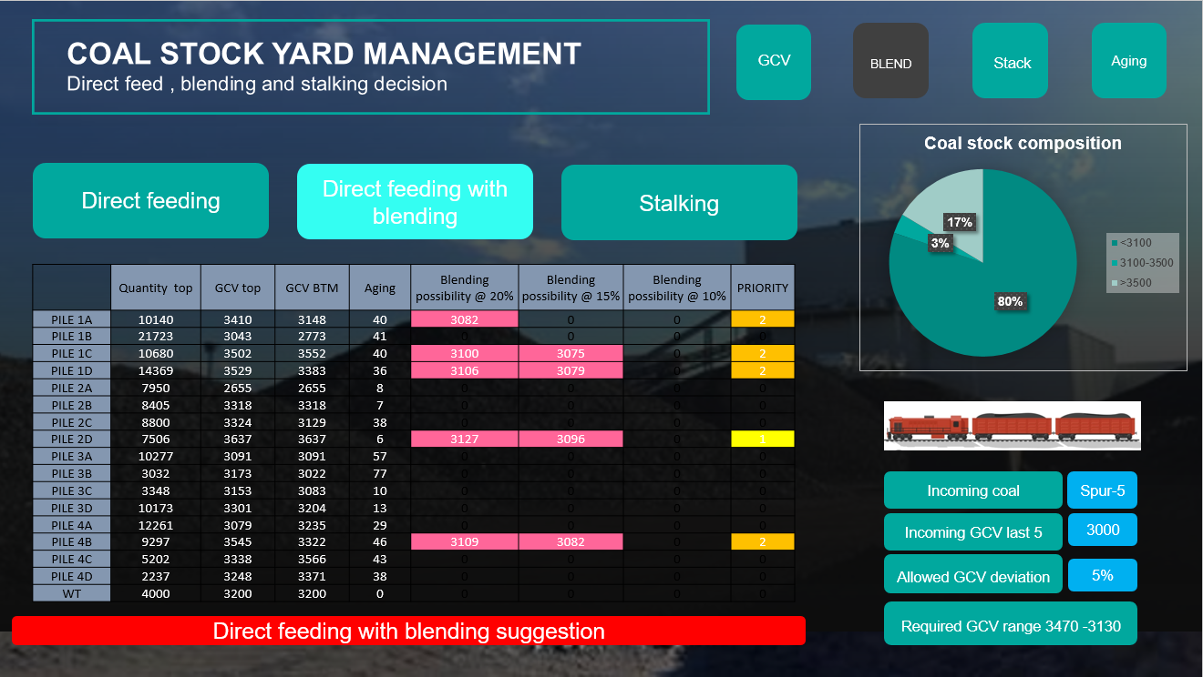

**Blending percentage and identification**

CYMS will try to give GCV within allowable range with blending ratio ( 20%, 15% and 10%)

*** Multiple pile blending is not consider.

Priority will be consider in case of multiple blending option which will consider

1. Aging of pile
2. GCV gap between top and bottom coal. (To make bottom coal approachable)